Name of the applicant’s Page No: 1/2
Mrs. Gavini Leela Kumari
Mr. Palaparthi Venkata Naga Srinivas
Gaddam Venu
Jeevan Devandla
Gulivindala Sri Lakshmi Sarojini
Doppalapudi Sri Sai Teja
Mudraboina Durgarao
Bapatla Engineering College

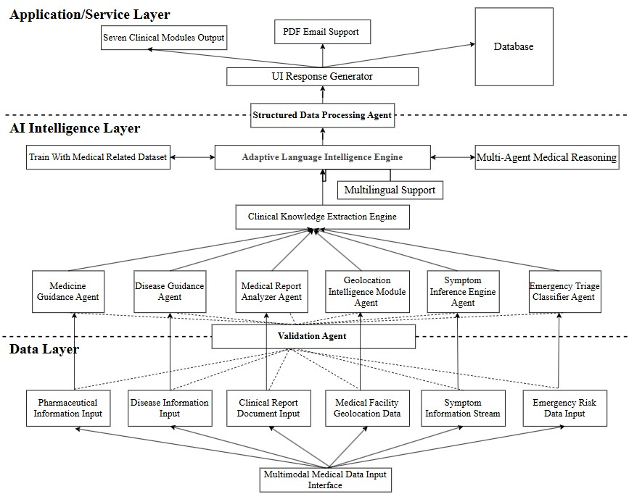
FIG 1 Multi-Layer Intelligent Medical Assistance System Architecture
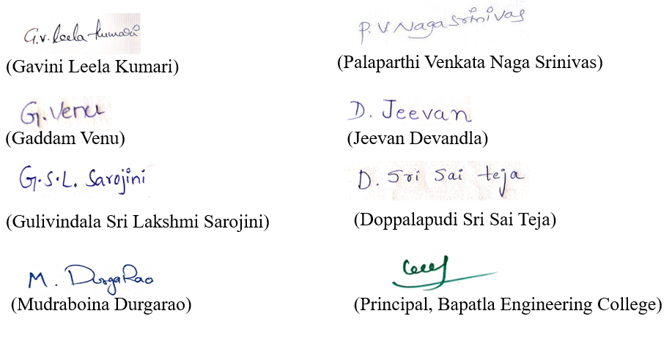

Name of the applicant’s Page No: 2/2
Mrs. Gavini Leela Kumari
Mr. Palaparthi Venkata Naga Srinivas
Gaddam Venu
Jeevan Devandla
Gulivindala Sri Lakshmi Sarojini
Doppalapudi Sri Sai Teja
Mudraboina Durgarao
Bapatla Engineering College
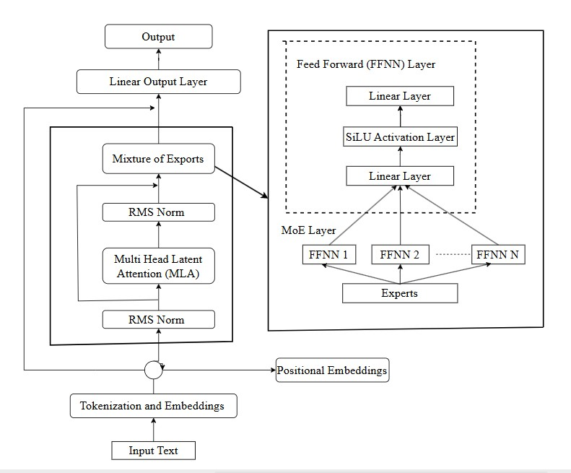
FIG 2 Illustrative Architecture of a Transformer-Based Language Model Including a Mixture-Of-Experts Processing Layer 

